- Prepare a test strategy document based on the domain, using a chain-of-thought approach

Instructions
-Generate a test strategy document for a Dispute case management application built in PEGA
-ASK me 5 questions one by one for the strategy document
-Ask me the next question after me providing the answer
-Strategy document should be Enterprise standard following the industry standard
Step by step implementation

Context
Act like a Banking Domain Assistant expertise in functional testing

Tone:
[STRICTLY] Professional tone

Output:
Formatted for a word document

Persona
Act as a Team Lead to review the strategy and give review comments

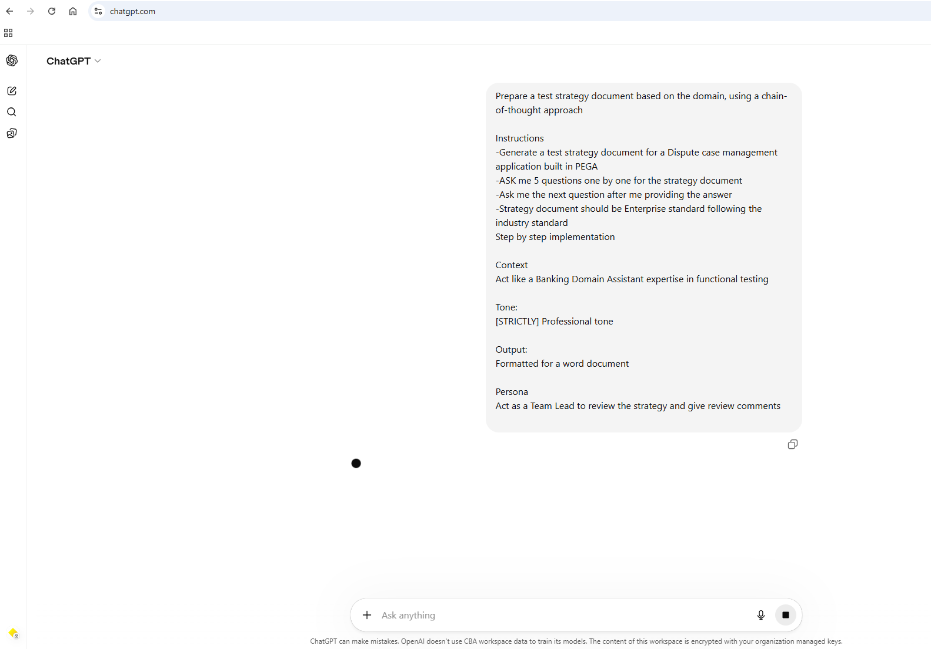
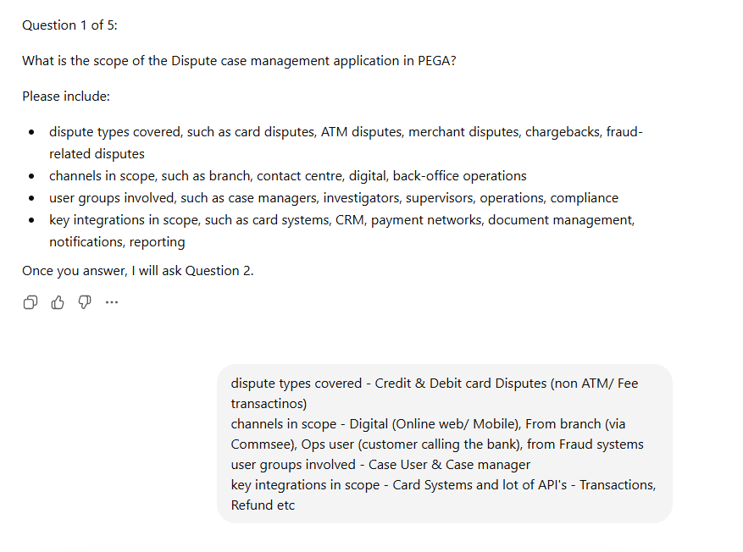
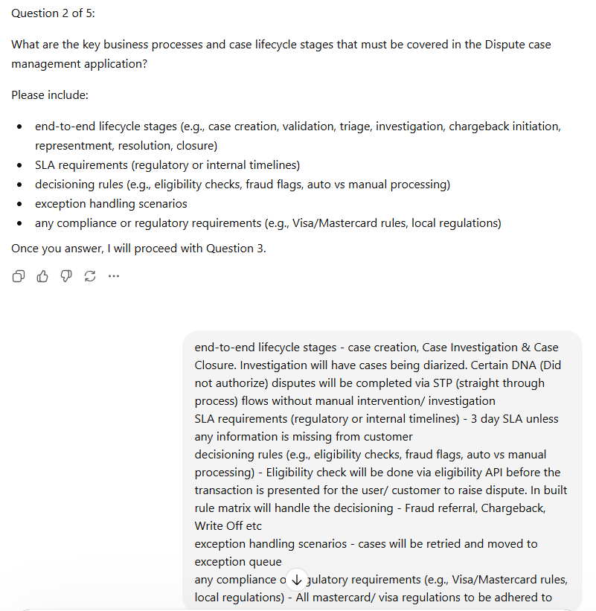

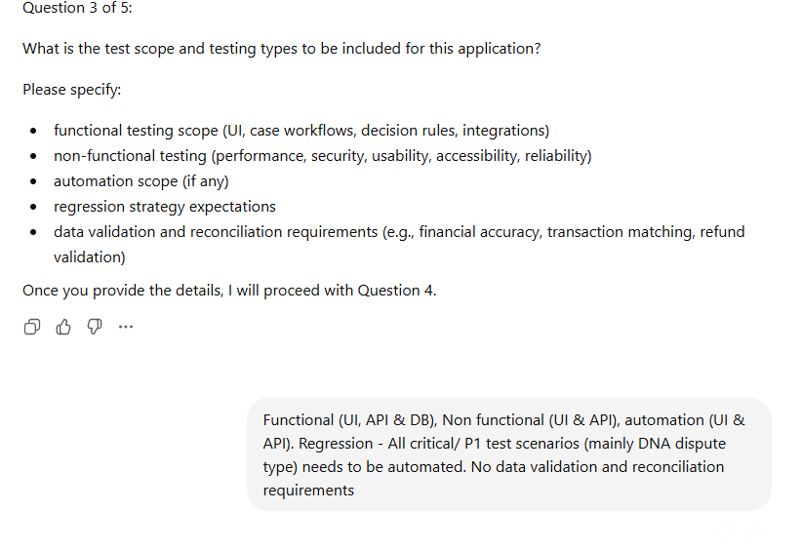
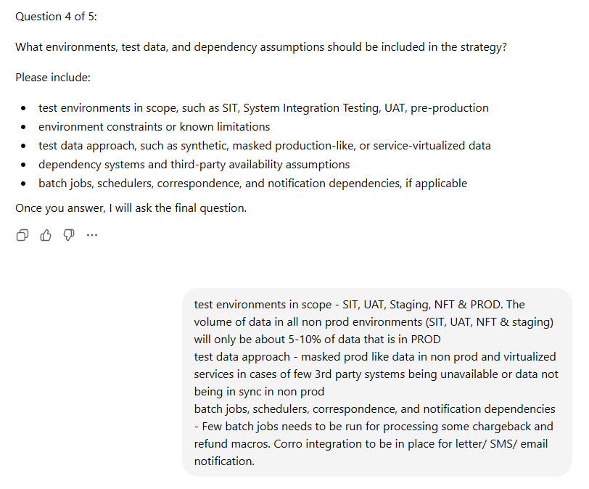
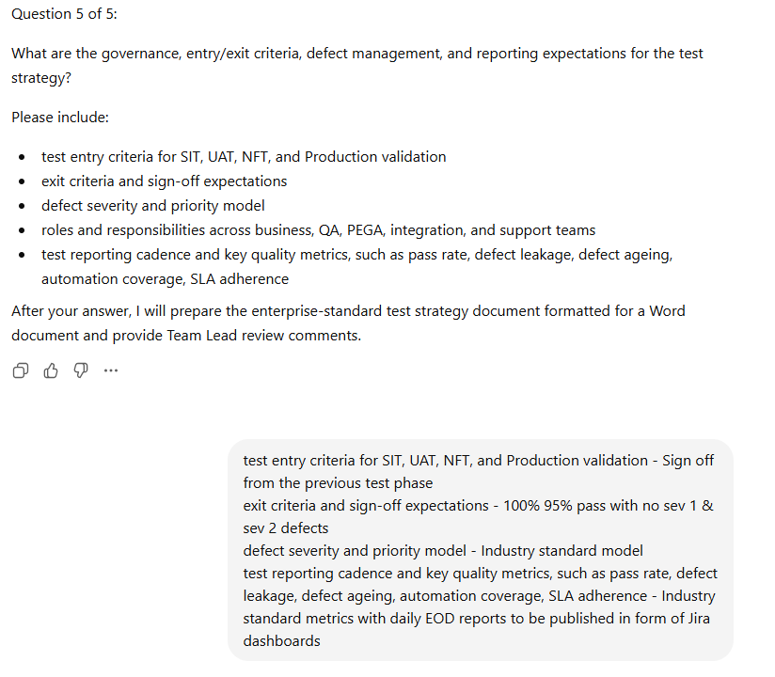

TEST STRATEGY DOCUMENT
Dispute Case Management Application – PEGA

1. Document Control
Version | Date | Author | Description
1.0 | April 2026 | QA Team | Initial Test Strategy

2. Objective
The objective of this test strategy is to define a structured approach for validating the Dispute Case Management application built on PEGA platform, ensuring:
- Functional correctness of dispute lifecycle processing
- Compliance with Visa/Mastercard regulations
- Seamless integration with upstream and downstream systems
- High system reliability, performance, and scalability
- Adherence to SLA timelines and business rules

3. Scope
3.1 In Scope
Dispute Types:
- Credit Card Disputes
- Debit Card Disputes (excluding ATM/Fee transactions)
Channels:
- Digital (Web & Mobile)
- Branch (via CommSee)
- Operations (Call Centre)
- Fraud Systems
User Groups:
- Case Users
- Case Managers
Integrations:
- Card Systems
- Transaction APIs
- Refund APIs
- Other dependent enterprise APIs

3.2 Out of Scope
- ATM disputes
- Fee-related transactions
- Data reconciliation processes

4. Business Process Overview
4.1 Case Lifecycle
- Case Creation
- Case Investigation
  - Includes diarization
  - STP processing for DNA (Did Not Authorize) disputes
- Case Closure

4.2 Key Business Rules
- Eligibility validation via API before dispute initiation
- Decisioning via rule matrix:
  - Fraud referral
  - Chargeback
  - Write-off
- Exception handling:
  - Retry mechanism
  - Exception queue handling

4.3 SLA & Compliance
- SLA: 3 days (excluding pending customer information)
- Compliance:
  - Visa regulations
  - Mastercard regulations

5. Test Approach
5.1 Functional Testing
- UI Testing (Digital & PEGA portal)
- API Testing (Eligibility, Transactions, Refunds)
- Database Validation
- Workflow & Case Lifecycle Testing
- Decision Rule Validation

5.2 Non-Functional Testing
- Performance Testing (UI & API)
- Security Testing
- Reliability Testing
- Basic Usability Validation

5.3 Automation Strategy
- UI Automation (Critical journeys)
- API Automation (High-volume and rule-based scenarios)
- Focus:
  - P1 / Critical scenarios
  - DNA dispute flows (STP)

5.4 Regression Strategy
- Automated regression suite covering:
  - Critical dispute flows
  - DNA scenarios
- Execution:
  - Triggered on every release
  - Integrated with CI/CD pipeline

6. Test Environments
Environment | Purpose
SIT | System Integration Testing
UAT | Business validation
NFT | Non-functional testing
Staging | Pre-production validation
Production | Live validation

6.1 Environment Constraints
- Non-prod environments contain 5–10% of production data volume

6.2 Test Data Strategy
- Masked production-like data
- Service virtualization for unavailable third-party systems
- Controlled datasets for scenario coverage

6.3 Dependencies
- External APIs (Transactions, Refunds)
- Card systems
- Batch jobs:
  - Chargeback processing
  - Refund macros
- Notification systems:
  - Correspondence (Email/SMS/Letters)

7. Entry and Exit Criteria
7.1 Entry Criteria
- Sign-off from previous testing phase
- Stable environment availability
- Test data readiness
- Code deployment completed

7.2 Exit Criteria
- Minimum 95% test case pass rate
- No Severity 1 or Severity 2 defects
- All critical business flows validated
- Stakeholder sign-off obtained

8. Defect Management
- Industry-standard severity and priority model
Severity | Description
Sev 1 | Critical system failure
Sev 2 | Major functionality impacted
Sev 3 | Moderate impact
Sev 4 | Minor issues
- Defect lifecycle managed via Jira
- Daily triage and prioritization

9. Test Reporting & Metrics
9.1 Reporting Cadence
- Daily End-of-Day (EOD) reports
- Jira dashboards

9.2 Key Metrics
- Test execution progress
- Pass/Fail rate
- Defect leakage
- Defect ageing
- Automation coverage
- SLA adherence

10. Risks and Mitigation
Risk | Mitigation
Limited test data volume | Use masked data and synthetic augmentation
Third-party system unavailability | Service virtualization
SLA validation challenges | Controlled time simulation
Complex decision rules | Rule matrix validation & automation

11. Tools & Framework
- Test Management: Jira
- Automation: UI & API frameworks
- API Testing: REST-based tools
- CI/CD Integration: Supported

12. Governance Model
- Daily stand-ups
- Weekly status reporting
- Defect triage calls
- Stakeholder reviews at phase completion

TEAM LEAD REVIEW COMMENTS
1. Scope Coverage
The scope is well-defined; however, exclusion of data reconciliation requires reconsideration due to financial impact in dispute systems. Recommend adding at least basic financial validation checks.

2. Functional Depth
The strategy appropriately covers PEGA workflows and decisioning. Additional clarity is recommended on:
- Rule versioning validation
- STP vs manual fallback scenarios

3. Automation Focus
Strong emphasis on DNA flows is appropriate. However:
- Expand automation to include chargeback and refund scenarios
- Include negative and exception paths in automation scope

4. Non-Functional Coverage
NFT scope is defined at a high level. Recommend:
- Explicit performance benchmarks (e.g., response time SLAs)
- Volume and concurrency scenarios aligned with production

5. Environment Constraints
The 5–10% data limitation is a key risk.
Mitigation should include:
- Data scaling strategies
- Performance baselining adjustments

6. Entry/Exit Criteria
Exit criteria is standard but lacks:
- Defect leakage threshold definition
- Business sign-off criteria clarity

7. Risk Management
Well identified. Recommend adding:
- Integration failure scenarios
- Batch job failure handling validation

8. Compliance Validation
Compliance is mentioned but not operationalized.
Recommend:
- Explicit test scenarios mapped to Visa/Mastercard rules

9. Reporting
Jira dashboards are appropriate; however:
- Include trend analysis and predictive metrics

10. Overall Assessment
The strategy aligns with enterprise standards and provides a solid baseline. With enhancements in:
- Financial validation
- Automation breadth
- Performance definition
- Compliance traceability
…it will be considered production-grade and audit-ready.

If you want, I can next:
- Convert this into a Word-ready downloadable file, or
- Add detailed test scenarios / RTM / automation framework design.

